Step Wise procedure to run the application:

1. Download and Install Python

<https://www.python.org/downloads/>

1. Set Environment Path Variable for python

(follow the steps provided at <https://www.liquidweb.com/kb/how-do-i-set-system-variable-path-for-python-on-windows/>)

1. Install virtualenv by running “**py -m pip install --user virtualenv**” in command promt.

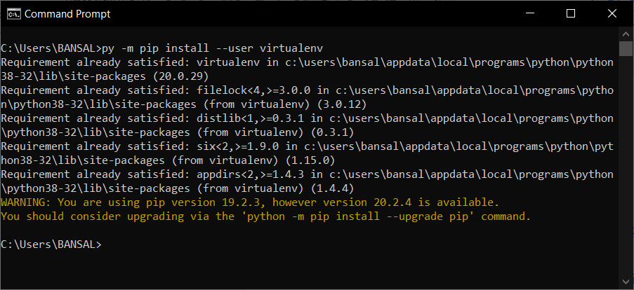

1. Now create a separate folder (for example “my project”) and create a virtual environment named as “VE” inside the folder

Use these commands to create virtual environment

* 1. virtualenv VE(to create virtual environment)
  2. cd VE/Scripts
  3. activate(to activate the virtual environment)

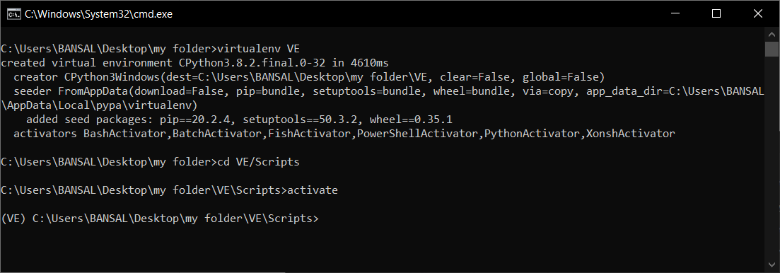

1. Now clone the project from the github

Github link : <https://github.com/jatin2810/nokia_project.git>

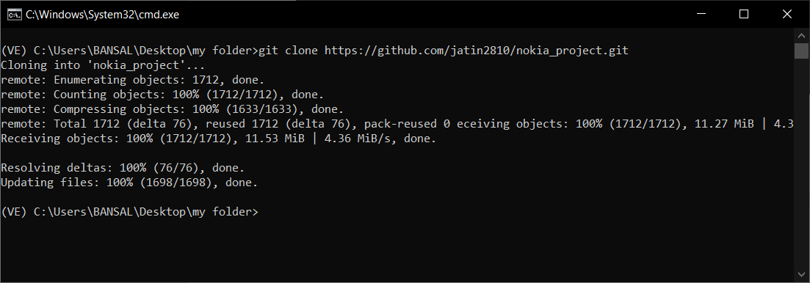

1. Move into the “nokia_project” folder by using “**cd nokia_project”** command and then install the requirements of the project by using “**pip install –r “requirements.txt”** in command prompt.

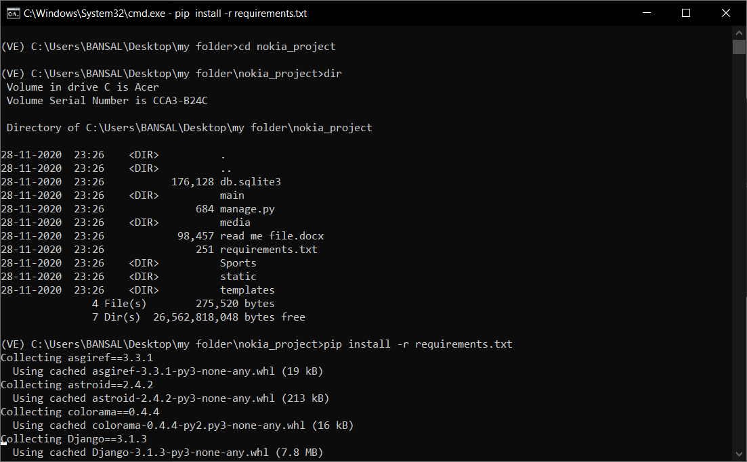

1. Now run “python manage.py runserver” command in the same directory.

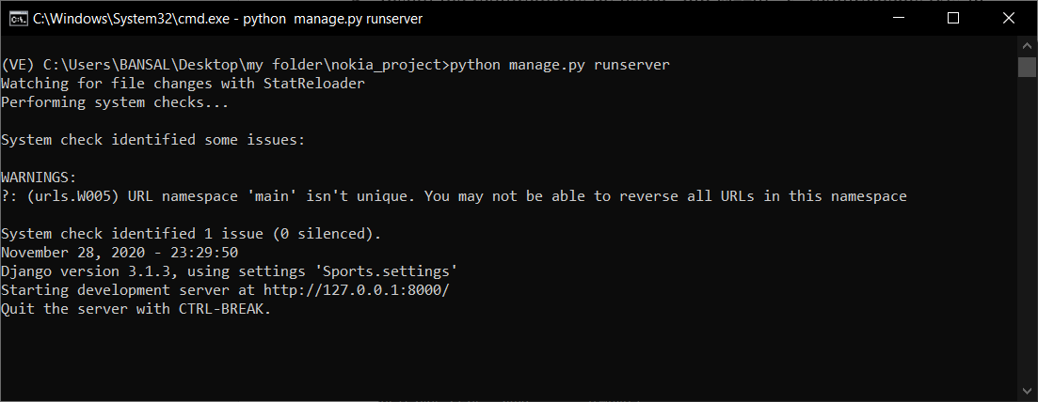

1. Now open <http://127.0.0.1:8000/> (localhost) url in the browser to see the website.

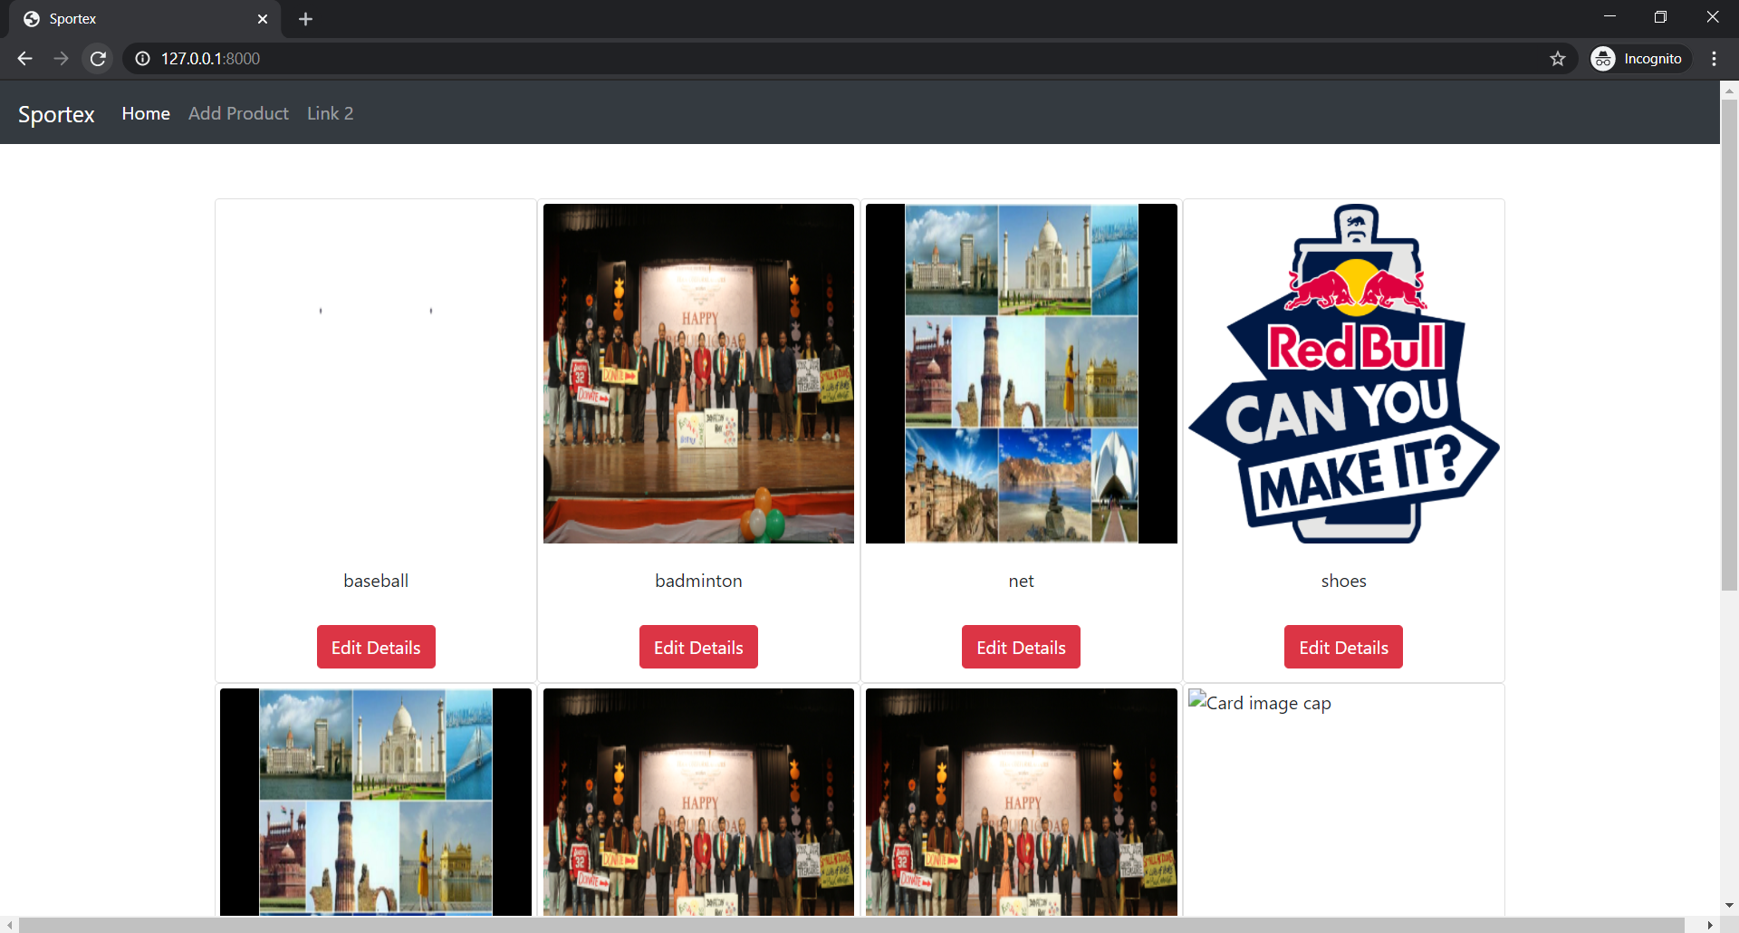

1. Different URLS for API calls
   1. To list the product : <http://127.0.0.1:8000/api/list> (paginate)
   2. To list the product: <http://127.0.0.1:8000/api/list1> (without pagination)
   3. To create a product: <http://127.0.0.1:8000/api/create>
   4. To get details of a product by name : <http://127.0.0.1:8000/api/detail/>
   5. To delete a product by name : <http://127.0.0.1:8000/api/delete/>
   6. To update a product by name : <http://127.0.0.1:8000/api/update?name=baseball> (name should contain the name of product)